- Create a NumPy array containing the integers from 1 to 20.
Perform the following operations:
- Display the array.
- Find the shape of the array.
- Find the maximum and minimum values.
- Calculate the mean and standard deviation.
- Reshape the array into a 4 × 5 matrix.
- Display the second row of the matrix.
- Display the third column of the matrix.
CODE:
import numpy as np
arr = np.arange(1, 21)
print("Array:")
print(arr)
print("Shape:", arr.shape)
print("Maximum value:", arr.max())
print("Minimum value:", arr.min())
print("Mean:", arr.mean())
print("Standard Deviation:", arr.std())
matrix = arr.reshape(4, 5)
print("4 x 5 Matrix:")
print(matrix)
print("Second Row:")
print(matrix[1])
print("Third Column:")
print(matrix[:, 2])
OUTPUT:
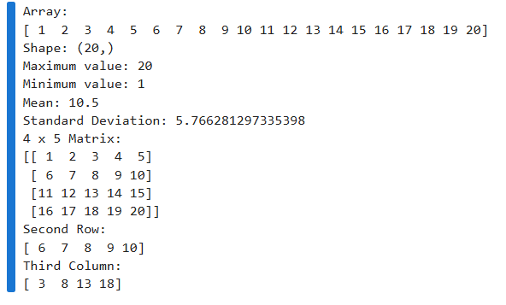
- Create two NumPy arrays: A = [10, 20, 30, 40, 50] B = [5, 10, 15, 20, 25]
Perform:
- Addition of A and B.
- Subtraction of B from A.
- Element-wise multiplication.
- Element-wise division.
- Find the sum of all elements in A.
CODE:
import numpy as np
A = np.array([10, 20, 30, 40, 50])
B = np.array([5, 10, 15, 20, 25])
print("Addition (A + B):")
print(A + B)
print("\nSubtraction (A - B):")
print(A - B)
print("\nMultiplication (A * B):")
print(A * B)
print("\nDivision (A / B):")
print(A / B)
print("\nSum of elements in A:")
print(np.sum(A))
OUTPUT:
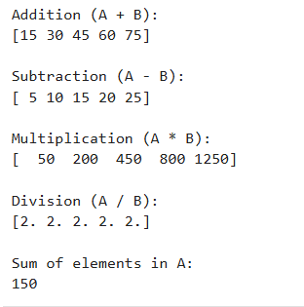
- Create a Data Frame using the following student data:
Roll No Name Marks
101 Ravi 85
102 Priya 92
103 Kiran 78
104 Anu 88
- Sita 95
Perform the following operations:
- Display the Data Frame.
- Display the first three records.
- Find the average marks.
- Find the student with the highest marks.
- Find the student with the lowest marks.
- Add a new column called "Grade" using:
- A for Marks ≥ 90
- B for Marks between 80 and 89
- C for Marks < 80
CODE:
import pandas as pd
data = {
"Roll No": [101, 102, 103, 104, 105],
"Name": ["Ravi", "Priya", "Kiran", "Anu", "Sita"],
"Marks": [85, 92, 78, 88, 95]
}
df = pd.DataFrame(data)
print("DataFrame:")
print(df)
print("First Three Records:")
print(df.head(3))
print("Average Marks:")
print(df["Marks"].mean())
print("Student with Highest Marks:")
print(df.loc[df["Marks"].idxmax()])
print("Student with Lowest Marks:")
print(df.loc[df["Marks"].idxmin()])
def grade(mark):
if mark >= 90:
return "A"
elif mark >= 80:
return "B"
else:
return "C"
df["Grade"] = df["Marks"].apply(grade)
print("DataFrame with Grade Column:")
print(df)
OUTPUT:
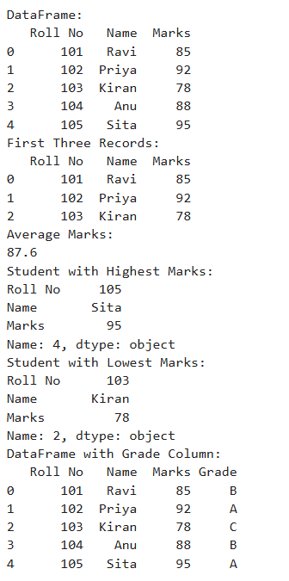
- Create a Data Frame containing the following information:
Product Price Quantity
Laptop 50000 10
Mouse 500 50
Keyboard 1200 30
Monitor 10000 15
Perform:
- Calculate the total value of each product using:
Total Value = Price × Quantity
- Add the Total Value column.
- Find the product with the highest total value.
- Calculate the overall inventory value.
CODE:
import pandas as pd
data = {
"Product": ["Laptop", "Mouse", "Keyboard", "Monitor"],
"Price": [50000, 500, 1200, 10000],
"Quantity": [10, 50, 30, 15]
}
df = pd.DataFrame(data)
df["Total Value"] = df["Price"] * df["Quantity"]
print("DataFrame with Total Value:")
print(df)
inventory_value = df["Total Value"].sum()
print("\nOverall Inventory Value:")
print(inventory_value)
OUTPUT:
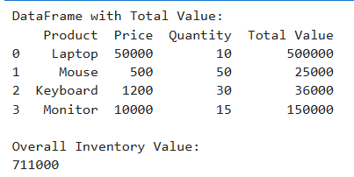
- Download the Iris dataset from Scikit-learn and perform the following:
- Load the dataset into a Pandas Data Frame.
- Display the first five records.
- Find the number of rows and columns.
- Display column names.
- Check for missing values.
- Generate summary statistics using describe ().
- Find the number of samples belonging to each class.
CODE:
import pandas as pd
from sklearn.datasets import load_iris
iris = load_iris()
df = pd.DataFrame(iris.data, columns=iris.feature_names)
df["Species"] = iris.target
df["Species"] = df["Species"].map({
0: "setosa",
1: "versicolor",
2: "virginica"
})
print("Iris DataFrame:")
print(df)
print("First Five Records:")
print(df.head())
print("Number of Rows and Columns:")
print(df.shape)
print("Column Names:")
print(df.columns)
print("Missing Values:")
print(df.isnull().sum())
print("Summary Statistics:")
print(df.describe())
print("Samples in Each Class:")
print(df["Species"].value_counts())
OUTPUT:
